12.05
Customer Quotations
Process Design & AMOS Configuration Document
Purpose
This Process Design document is provided to Key-Users to record their key decisions regarding the AMOS Process design and the required AMOS configuration.
It is updated throughout the Project Definition Phase and used as the baseline for the Final Acceptance prior to Go-Live
Revision
Author, Name | Date | Notes
Doncho Ivanov | 01.06.2024 | First Version

Table of Contents
1. Process Overview & Objectives 3
2. Regulatory References 3
3. Definitions & Glossary 3
4. Process Tasks 4
5. Process Dependencies 5
6. Process Flow 6
7. Process Design Questions 8
What sections do you differentiate in the final customer invoice? e.g. Routine work, Findings etc. 8
8. Data Source Mapping 10
9. Other Software Used 10
10. AMOS Configuration 11
a. Process specific configuration programmes 11
b. Basic Data 11
c. Parameters 12
d. Workflows 13
e. Scheduled Tasks 13
f. API’s & Interfaces 14
11. UAT Guidance 14
12. Annex – Additional Info 15

Process Overview & Objectives
Process General Description:
This process describes a flow of tasks aiming to facilitate the engagement with customers regarding MRO maintenance activities – from establishing the first contacts, by means of promoting marketing campaigns, to the actual initiation of the maintenance work in the MRO maintenance facilities, following already won bids.
It also includes the tasks needed for creating new customer quotations for maintenance activities, such as Aircraft Heavy checks and Shop visits, as well as for Material supplies. The actions of setting up the quotation pricing conditions, and quotation scope are of particular importance, as well as the subsequent potential revisioning of the quotation scope, due to the direct impact on billing.
The process is usually initiated by the Sales/Commercial department of the organisation by launching marketing campaigns to the customer base or by generating quotations after already received maintenance requests. This process has an input from-, output to- and interaction with several other concurrent processes, which makes the process complex due to its dependencies. Therefore, thorough understanding of the overall flow is required. This process is continuously performed as it is an integral part of the overall order-to-cash (O2C) process.
Main Process Objective (Outputs & Outcomes):
The main objective of this business process is, on the one hand, to manage relationship with customers, as well as pre-sales activities with potential or existing customers, and on the other hand, to create and manage customer RFP and quotations from receiving customer service request, estimating the received scope of work and applying appropriate pricing conditions to it, revisioning the same, as required, to obtaining customer decision on the quoted scope of work.
The execution of this business process promotes the MRO/Shop new- or existing capabilities to potential- and existing customers, supporting the overall objective of the organisation for running a profitable business by providing more services to growing customer base. It also provides immediate overview of the state of participation in the bidding process by means of different quotation statuses, enabling further analyses, especially on lost and/or self-cancelled bids.

Regulatory References
There is no worldwide authority regulation applicable to this process.

Definitions & Glossary
Key-Words | Explanation
GTA | General Terms of Agreement
AMA | Airframe Maintenance Agreement
RFQ | Request for Quotation
RFP | Request for Proposal
CRM | Customer Relationship Management
Lump sum | Single sum of money that serves as complete payment
MQ (Maintenance quotation) | Quotation type used to quote usually heavy aircraft maintenance services such as checks or task cards
S-MQ (Shop Maintenance Quotation) | Quotation type used to quote shop maintenance services such as repairs and component maintenance projects
MSQ (Material supply Quotation) | Quotation type used to offer material supply and/or material sale services to customers such as loans or sales.
Campaigns | Marketing promotions, e.g. roadshows, conferences, brochures
Visit | Aircraft Base Maintenance Event
Activities | Can be anything that is done for a specific customer, e.g. email correspondences, on-site visits, phone calls

Process Tasks
Business Process Task / Actions / Activities:
- Receive incoming requests for MRO input: Involves the receipt, management, incl. creation of Customer Visits and verification of MRO capability and internal resource availability, of incoming requests for MRO maintenance input. This task is concluded by confirming or rejecting the feasibility of executing the customer maintenance request.
- Initiate presales activities & marketing campaigns: Includes the initiation of activities to promote new- or existing capabilities to potential new- or existing customers, with the objective to generate revenues from higher volume of services and to increase the customer base.
- Generate aircraft maintenance quotation: Includes the generation, publication (for internal approval), revisioning and status confirmation of quotations, usually for heavy check maintenance input of customer’s aircraft. Defining the appropriate pricing conditions and the scope of work, as provided by the customer, as well as the breakdown of the scope in quotation chapters, is covered in the stage of quotation generation.
- Generate component maintenance quotation: Includes the generation, publication (for internal approval), revisioning and status confirmation of quotations for shop visit of customer’s component. Defining the appropriate pricing conditions and the scope of work, as provided by the customer, as well as the breakdown of the scope in quotation chapters, is covered in the stage of quotation generation.
- Generate component supply quotation: Includes the generation, publication (for internal approval), revisioning and status confirmation of quotations for material supplies to customers.
- Release quotations for internal approval: Includes the official authorisation to generated quotations prior publishing to customer as per set of predefined rules, complying with the approval limits set in the organisation.
- Manage changes in already approved scope (increase/decrease): When it is necessary to make changes in already approved quotation scope, this may be done by means of revising the entire already approved scope; by generating a sub-quotation, covering the scope increase only; and by generating deduction quotation, covering the scope decrease only.

Process Dependencies
INPUT | CONCURRENT | OUTPUT
- 07.02 – Hangar & Resources: Provide hangar space and resource availability information to customer Visit in CRM.  - 09.01 – Material Planning: Provide material information to customer Visit in CRM.  - 07.03 – Work Templates: Define commercial MHs and pricing conditions for worktemplate(s).  - 11.02 – Shop Card Templates: Define commercial MHs and pricing conditions for shop card template(s).  - 12.04 – Commercial Pricing & Billing: Link Quotation to Customer contract and obtain relevant pricing conditions from CPL price repository. | - 07.06 – Customer MRO Workpackages: Generate WP for accepted AC maintenance Quotation.  - 10.07 – Customer Material: Initiate component receiving and CWP generation for accepted Shop maintenance Quotation.  - 08.02 – Performing Maintenance: Execute the scope of work as per WP.  - 11.04 – Component Maintenance: Execute the scope of work as per CWP.  - 09.03 – Ordering: Providing material and services as quoted to customers. | - 07.06 – Customer MRO Workpackages: Generate maintenance WP for released CRM workpackage.  - 10.07 – Customer Material: Generate maintenance CWP for release CRM workpackage.  - 12.04 – Commercial Pricing & Billing: Billable project items for quoted scope of work available for bill generation.

Process Flow
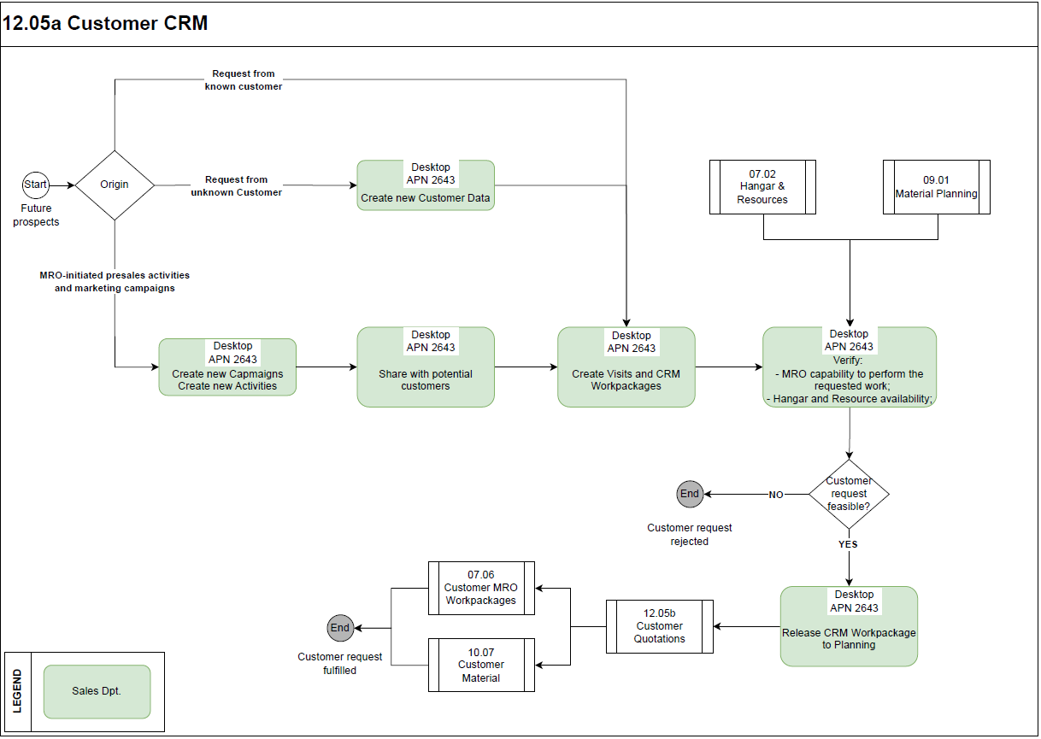
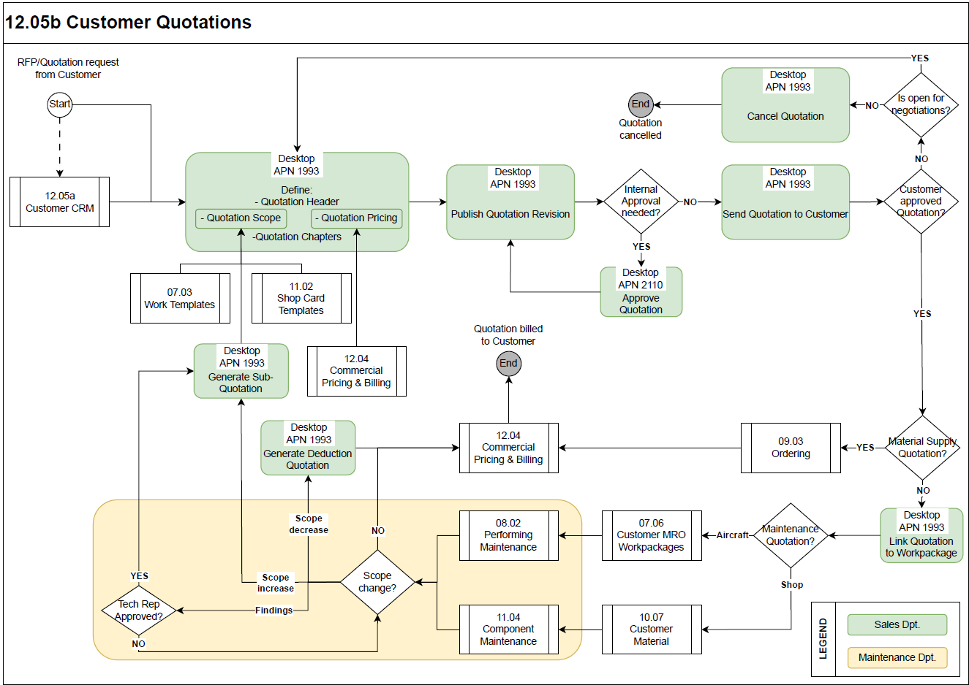

Process Design Questions
# | Question | Answer
1 | Do you have a department in charge of Customer Relationship (e.g. Marketing dept.)
2 | How do you communicate with your customers?  Do you have a dedicated platform to do so (e.g. approving findings, show component repair status)?
3 | What kind of information do you need to share with your customers?
4 | Do you have a dedicated department to produce quotation (Marketing / Production Planning / Commercial /Sales etc.)?
5 | What activities do you quote for? e.g. Line/Base/Component maintenance, Material supplies etc.
6 | Do you use CAP conditions in maintenance quotations?
7 | Do you exclude tools or any parts from the quote? E.g. parts related to Cargo and Cabin compartments.
8 | Are you going to migrate all your data into AMOS in order to create quotations for currently ongoing maintenance projects? (Manhours / Parts / Costs)
9 | What sections do you differentiate in the final customer invoice? e.g. Routine work, Findings etc.
10 | What shops are present in your organisation? What shop maintenance activities do you need to quote for? e.g. component repair, overhaul, modification; tool calibration etc.
11 | Do you need to quote for the given scope before inspecting the component?
12 | Is there already agreed/fixed price as per a customer contract for given maintenance scope? E.g. minor repair charged fixed price as per contract + additional work quoted separately upon component inspection.
13 | Do you supply components to customers, e.g. sale, exchange or loan-out?
14 | Do you need to quote for supplying components to customers?
15 | Are surcharge pricing conditions inheritable from Main Quotation to Sub Quotations?
16 | How is the change in maintenance scope approved, e.g. for findings, for additional work etc.?
17 | How is the change in maintenance scope charged, e.g. fixed price vs T+M?
18 | How is the change in already quoted and agreed scope handled? Do you issue a credit note for it?

Data Source Mapping
Data Sources | Description | Volume / Manual / Automatic / Static / Dynamic
-/- | -/- | -/-

Other Software Used
Other Software | Used by: | Description
-/- | -/- | -/-

AMOS Configuration

Process specific configuration programmes
AMOS APN | Notes
APN: 355 Currencies | Define the list of necessary foreign currency codes.
APN: 53 Address Administration – Property tab | Set the Property codes = ‘CT’ and ‘CR’
APN: 1848 Work Template Manager | Define sales hours on estimated work quotable to customer.
APN: 3301 Define Commercial Man-Hours | Define sales hours on performed work billable to customer as T+M.
APN: 2111 Approval Control Configuration | Configure the rules for approval of quotations, according to applicable Delegation of Authority / Limits of Authority policy of the organisation.
APN: 14 Admin Logins | Define the user logins and assign them to user roles.
APN: 15 Admin Roles | Define user roles and assign access rights (licenses) to each of them.
APN: 146 Staff Management | Define employee data. Link each employee to Financial entity. Define staff qualification (skill/scope), used in time booking.

Basic Data
Basic Data Table | Notes
Planning Qualifications | Define Skill and Scope of technicians (Skills and Scope to be linked to Commercial Type of Work).
Type of work (Commercial) | Define types of work, i.e. commercial equivalents of planning qualifications or MH charging groups. Types of work may be generic (e.g. qualified, not qualified, NDT etc.) or detailed - corresponding to the planning qualification
Cancellation Reason | Defines the Cancellation reasons available in Quotation Manager
CRM Activity Categories | This table contains categories for CRM Activities. A category defines the type of an Activity.
CRM Activity Group States | This table contains the states for CRM Activity Groups. Each status can be defined to be treated as "Open" or "Closed". An Activity Group with a Status defined as "Closed" will not appear when searching for open Activity Groups.
CRM Activity Priorities | This table contains priorities for CRM Activities.
CRM Activity States | This table contains the states for CRM Activities. Each status can be defined to be treated as "Open" or "Closed". An Activity with a Status defined as "Closed" will not appear when searching for open Activities.
CRM Activity Tags | This table contains the tags for CRM Activities. A tag can be any additional information that has to be stored in the context of an Activity.
CRM Campaign Type | This table contains the types for CRM Campaigns.
CRM Contact Attributes | This table contains the attributes for CRM Contacts. An attribute can be any additional information that has to be stored in the context of an Contact.
CRM Customer Attributes | This table contains the attributes for CRM Customers. An attribute can be any additional information that has to be stored in the context of an Customer.
CRM Customer Classification | This table contains the classifications for CRM Customers. An classification allows to group customers in groups of interest (e.g. VIP Customers).
CRM Customer Mapping | The entries define codes for a mapping scheme when importing Customers in the Customer Relationship Management. With this helper table it is possible to map import values to existing values with a different vendor code (e.g. Swiss-AS could be mapped to SAS -> Swiss-AS will not be imported but SAS will be updated).
CRM Customer Type | This table contains the types for CRM Customers. An type allows to filter customers which are of a certain type (e.g. Leads).
CRM Visit Business Unit | The entries define codes for Business Units for Visits and Visit Steps in the Customer Relationship Management. Adding a new Business Unit will add an additional column in the Visit tab of the Customer Relationship Management APN. For each Business Unit it is possible to define allowed Business Unit Status (see entry "CRM Visit Business Unit Status" for more information). it is also possible to define the position of the Business Unit in the Visit and Visit Step table.
CRM Visit Business Unit Status | The entries define codes for possible states of Business Units in the Customer Relationship Management. A Business Unit Status comes with a color code which is the background color of the Business Unit in the Customer Relationship Management APN. It also has a severity which influences the forecasting of Business Unit development for future Visit Steps.
CRM Visit Status | This table contains the states for CRM Visits.
CRM Visit Type | This table contains the types for CRM Visits. This defines which type of actions can be performed during a Visit.

Parameters
Parameter Code | Parameter Name | Notes
1805 | Default Rounding Strategy for Resource Time Requirement | This parameter defines the default strategy used to round the time requirement in Quotation Manager, in the Commercial Tab of Worktemplate manager and in Define commercial Man-Hours.
1470 | WORKPACKAGE GROUPS SETTINGS | [Str] Used to define default list of Commercial Groups created automatically for each Workpackage.  [Fl] If set to 1.0 the defined list of Commercial Groups will automatically be created in each Workpackage.
1699 | Combined MRO CRM Parameter 1 | This parameter stores the settings defined in the MRO CRM Configuration Dialog.
1705 | Combined MRO CRM Parameter 2 | This parameter stores the settings defined in the MRO CRM Configuration Dialog.

Workflows
Workflow Number | Workflow Name | Workflow Setup Notes
377 | CRM Visit Status Update | This workflow will be triggered when a status change in the CRM visit module for a visit or visit step was saved. With a rule you can access the content and other details of the saved update.
364 | Quotation Manager Control | This Workflow contains the quotation data and is triggered when the quotation changes its status, or by the scheduled task QuotationManagerNotificationTask.
618 | Quote Workpackage Workscope Mismatch | This Workflow will be triggered by the QuoteWPWorkscopeComparisonTask when a Quote Workscope does not match the Workscope of the linked Workpackage.
12 | Scheduler Task Message | Setup workflow to monitor the errors of the relevant scheduler task.

Scheduled Tasks
Scheduled Task Reference | Frequency | Notes
QuotationManagerNotificationTask | daily | Task that will run the Quotation Manager Control Workflow for each non archived quotation, matching the given task parameters.
QuoteWPWorkscopeComparisonTask | daily | This task will perform a comparison analysis between workpackages and their currently linked quotations. Performed analysis will look for:  - work scope items of the quote that are currently not planned in workpackages;  - Workpackage events that should be additionally quoted or deducted.
CrmCampaignMailDaemon | on demand | Daemon for sending CRM campaign emails at a specific time.

API’s & Interfaces
Reference | Direction | Trigger | Frequency
Import vCard file (*.vcf) into AMOS | Import to AMOS | Import new CRM contact | As required

UAT Guidance
Test case number | Test case description | Required data | Required resources
1 | Create new CRM customer. | Maintenance request from unknown customer. | Commercial / Sales
2 | Create new campaigns / activity / visits. |  | Commercial / Sales
3 | Create CRM Workpackage. | Created visit. | Commercial / Sales
4 | Request visit status update. | Created visit. | Commercial / Sales
5 | Release CRM Workpackage. | Created CRM Workpackage. | Commercial / Sales
6 | Generate quotation of different type. | Maintenance request from customer. | Commercial / Sales
7 | Upload quotation scope from file. | .txt file with the list of tasks to load. | Commercial / Sales
8 | Load pricing conditions to quotation from CPL. | Pricing conditions in CPL. | Commercial / Sales
9 | Define Fixed price quotation chapter. | Scope of work set as Fixed price. | Commercial / Sales
10 | Define T+M quotation chapter. | Scope of work set as T+M. | Commercial / Sales
11 | Generate (and/or link) Workpackage to/from quotation. | Accepted quotation. | Commercial / Sales
12 | Generate sub-quotation for findings and/or scope increase. | Additional non-quoted scope in Workpackage. | Commercial / Sales
13 | Generate deduction quotation for scope decrease. | Quotation approved scope deducted in linked Workpackage. | Commercial / Sales

Annex – Additional Info
-/-

